**The Karate Kid**

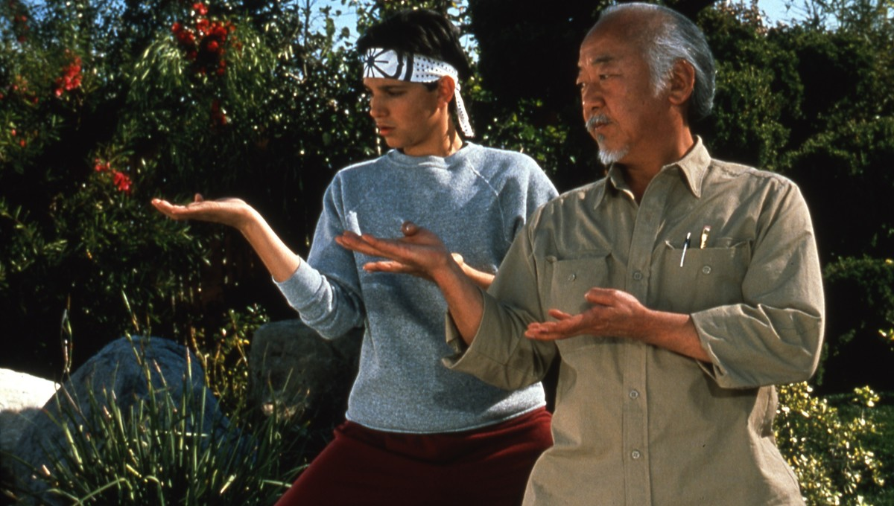

# The Karate kid movie show that we choose a coach and believe your coach and then coach provide the correct way of learning.

# Coach train the student from beginner level.

# Student should have believe in coach.

# Mentors want to provide a valuable practice experience for students but are constrained by multiple demands and limited resources.

# The mentor's role is paramount in student assessment and the mentor should receive the support necessary to enhance student learning.

Anirudh Sharma